**Assignment 7 (40 points)**

**Problem 1. Review of the main topics from image processing *(10/10)***

Briefly describe each one of the topics below. In your descriptions, include the advantages/disadvantages of each approach and an example of an application where the approach can be applied:

1. sampling
2. quantization
3. histogram equalization
4. Laplacian of Gaussian (LoG) edge detection
5. dilation
6. erosion
7. one topic not in the list above that you enjoyed

**Problem 2. Segmentation overview *(10/10)***

Briefly describe the segmentation techniques learned in this course and the relationships, if any, among them. You can also include a diagram to show the relationships. Pick one of these techniques and describe one application where you think it will be appropriate to use the technique.

**Problem 3. *(10/10)***

The image in Figure 1(a) below shows a gray level image. The images in the other parts correspond to low-passed, high-passed, or band-passed version of (a), not necessary in that order. Identify which of the images in (b), (c), and (d) is low-pass, which one is band-passed, and which one is high-passed? Justify your choices.

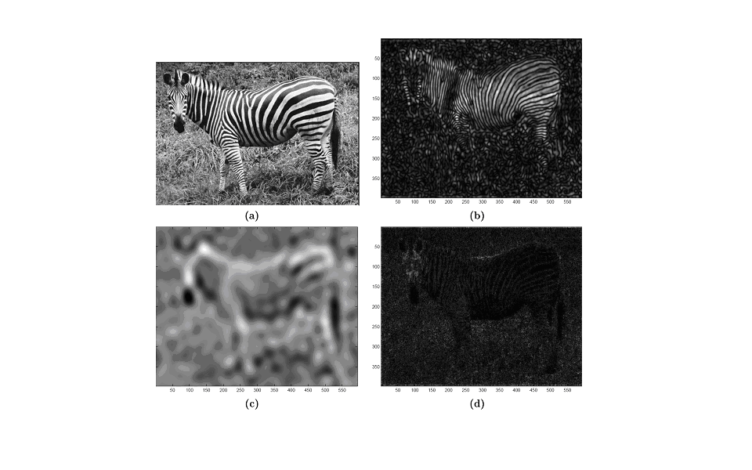

Figure 1: Figure for Problem 2

**Problem 4. *(10/10)*:**

Describe an algorithm to locate all of the large boxes in the image (Figure 2) below.



Figure 2: Image for Problem 4

**General submission instructions:**

1. Be kind to your aging, over-worked professor and submit only a single document. This can be pdf, MS Word, OpenOffice, etc. Do not submit a zip file.
2. Your single document should include the input image for your problem, if required, and answers to each of the sub-problems (text, image or both, as appropriate). Your document should also include code that you wrote to generate your answers.
3. You may use any images you like for the programming; I encourage you to use images that might be useful/interesting for your final project.
4. Feel free to use whatever functions MatLab supplies, except where otherwise specified. Also feel free to write your own, if you are so inclined; it will take more time, but you will gain a deeper understanding of the material. It is one thing, for example, to implement bicubic interpolation using the matlab resize, quite another to write a bicubic interpolator yourself.
5. Point values for each question are indicated as ***x/y*** in which ***x*** is the point value for 481 students and ***y*** is the point value for 381 students.